9.01. Return goods to a supplier
It is important to be able to return goods to a supplier without it being counted as goods being issued to a customer. If you just issue goods to your supplier through a Customer Invoice, then those goods will be counted as part of your store's 'issuance' (consumption ). A Supplier credit is the right way to return goods to a supplier.
Goods are returned to a supplier using a supplier credit transaction. There are two ways to create one:
- Manually create a supplier credit
- Create a supplier credit from a finalised supplier invoice

Manually create a supplier credit
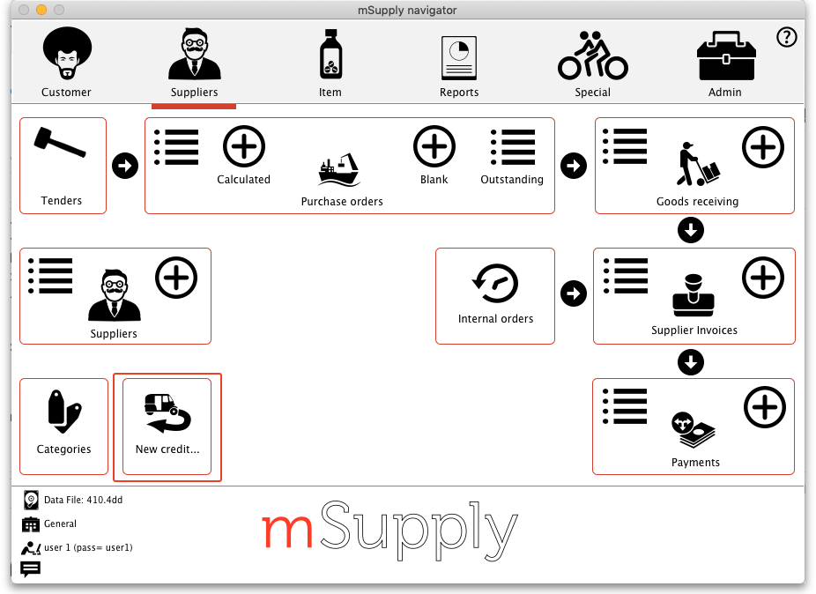
On the Suppliers tab of the navigator, click on the New credit… icon (Supplier > New supplier credit… in the menus):
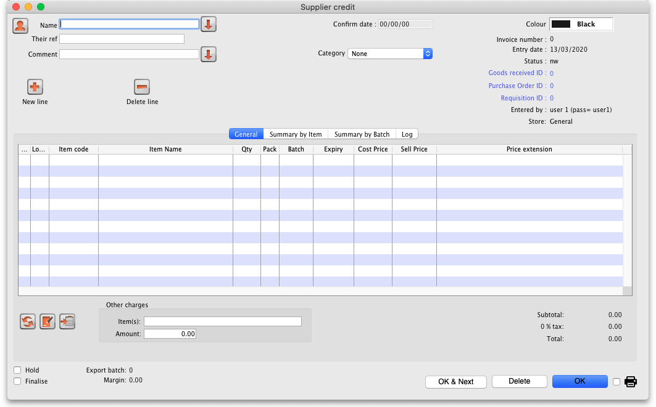
This will open the new supplier credit window:
In the Name text box, type the first few characters of the supplier's name then press the Tab key on the keyboard and select the correct supplier in the usual way. Enter a reference and comment in the Their ref and Comment fields if needed.
If the supplier is on hold you will be warned and asked if you wish to proceed with sending the goods back to them.
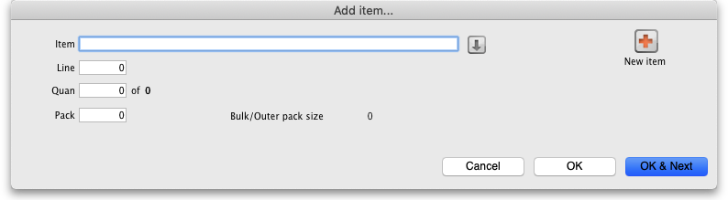
Now click on the New line button to open the new line window:
Just as you do on a customer invoice, you enter the name of the item and then select the line of stock you wish to return to the supplier (obviously, you're selecting what to return from what you already have in stock). So type the first few characters of the item's name or code in the Item field and press the tab key on the keyboard to select the item in the usual way. When you have selected the item, you will be shown the list of all batches you have in stock:
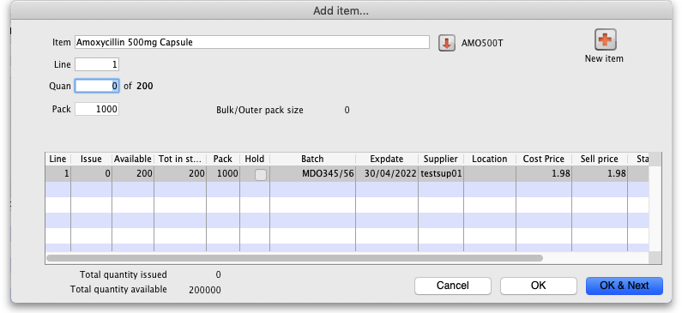
Enter the number of packs to return in the Quan field and click on OK or OK & Next if you want to add another item. When you've finished adding items you'll be back at the supplier credit window:
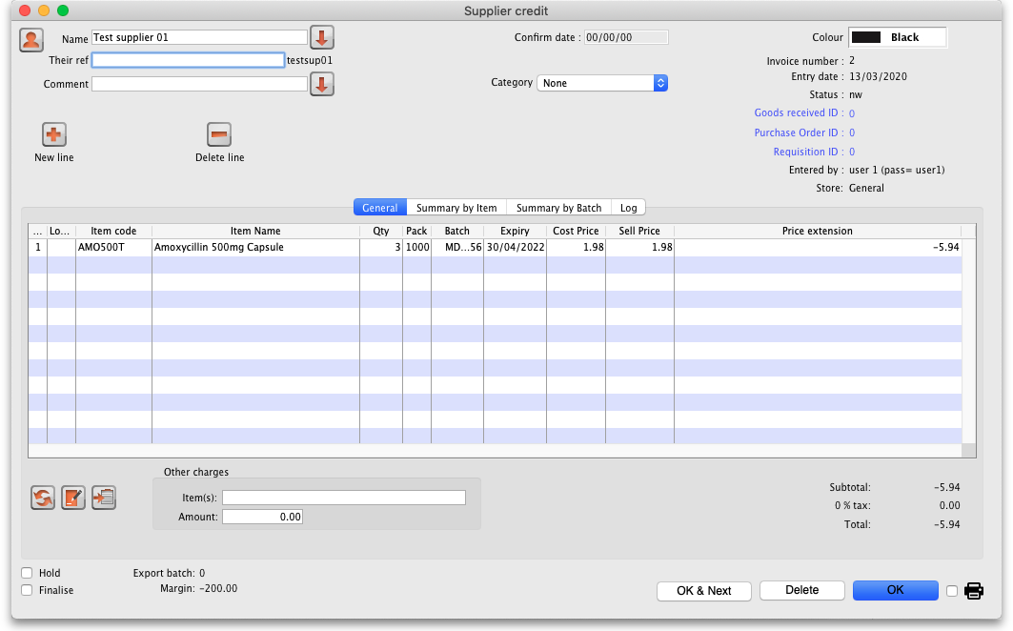
Click on the OK button and the supplier credit will be automatically confirmed and the stock will be taken out of your system. If you need to print out a packing list or delivery note the click on the printer icon on the bottom right hand corner of the supplier credit window before clicking on the OK button.

If the supplier is another store
If the supplier in the Name field is another store, mSupply will create an on-hold customer credit in that store so that the users there can easily receive the goods in when they physically arrive at their warehouse. However, just as with normal customer invoice stock transfers, the customer credit will only be created when this supplier credit is finalised. So, if you have not checked the Finalise checkbox on the supplier credit before you clicked on the OK button, you will be shown this confirmation message:
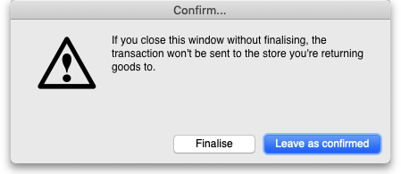
If you click on the Finalise button the supplier credit will be finalised and the customer credit will be created in the supplier store. If you click on the Leave as confirmed button the supplier credit will be left at confirmed status (so the goods will still have been deducted from your store) but the customer credit will not be created in the supplier store. You can open the supplier credit again later and finalise it to create the customer credit in the supplier store.
A note about transaction categories: If you have set a transaction category in the supplier credit (the Category field in the screenshot above) then, when the customer credit is created in the supplier store, mSupply will look for a customer credit category with the same category code. If it finds one then it will assign it to the customer credit, otherwise it will not assign a category to the customer credit.

Create a supplier credit from a finalised supplier invoice
If a user has the Return stock from supplier invoices preference set (see the 25.15. Managing users section for details), then, when they open a finalised supplier invoice, a Return selected lines button will be displayed:
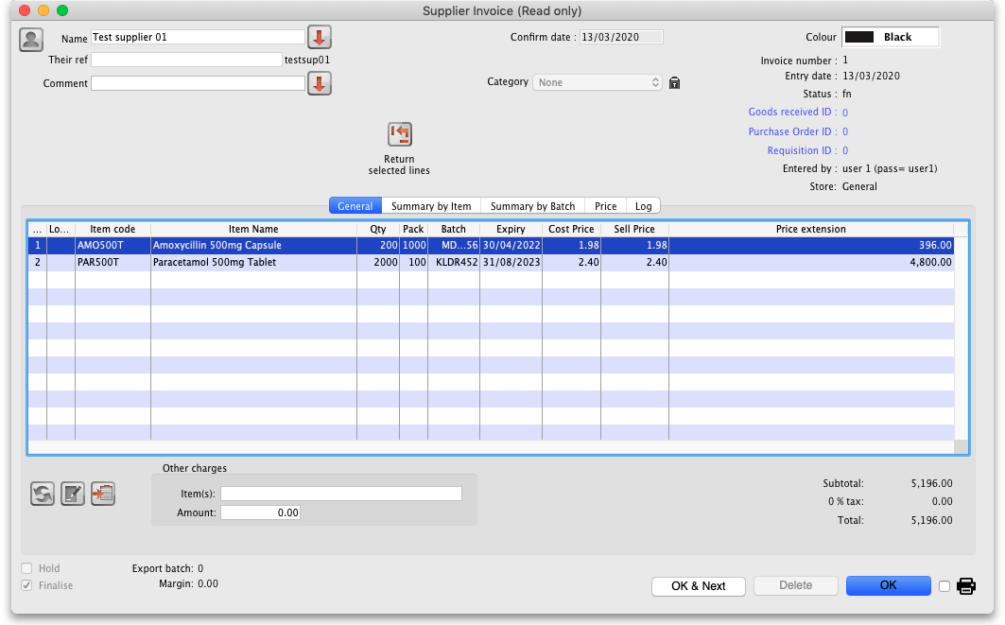
Select the lines you wish to return by clicking on them in the table (the usual Shift and Ctrl/Cmd+click and Ctrl/Cmd+A combinations are available) then click on the button to see the window where you enter the number of packs you wish to return:
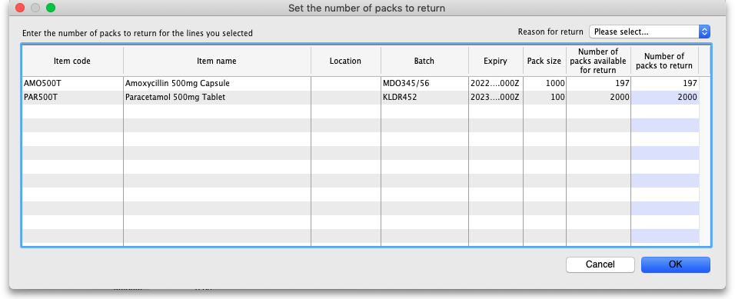
Each line you selected on the supplier invoice is shown in the table. In the Number of packs to return column, enter the number of packs you wish to return for each line. If you wish, select the reason for return in the drop down list in the top right hand corner of the window. This drop down list is populated with your supplier credit transaction categories (see the 22.07. Transaction categories section for details on this).
When you're done, click on the OK button. mSupply will check you have the quantity you selected in stock. If you do not, you will be warned and you must set a different quantity. If all is well you are asked for confirmation and then a finalised supplier credit (with the transaction category you selected in the Reason for return drop down list) is created for you, which you can view as described in Viewing supplier credits.
If the supplier is a store, you will be informed that a customer credit has automatically been created in the supplier's store, just as when you create a supplier credit manually. Note that, if you selected a reason for the return, mSupply will look for a customer credit transaction category with a code matching that of the reason you selected and, if it finds one, will apply that to the customer credit.
While the Supplier Credit is created from a Supplier Invoice, Legacy mSupply does not (yet) record the logical relationship between the Supplier Credit and the associated Supplier Invoice, Internal Order or Purchase Order. So the Supplier Credit does not have an impact of mSupply's record of outstanding lines in the Internal Order or Purchase Order. For this feature, you'll be wanting to use Open mSupply .

Viewing supplier credits
To view supplier credits you have created before, click on the show supplier invoice icon on the Suppliers tab of the navigator (Supplier > Show invoices… in the menus):
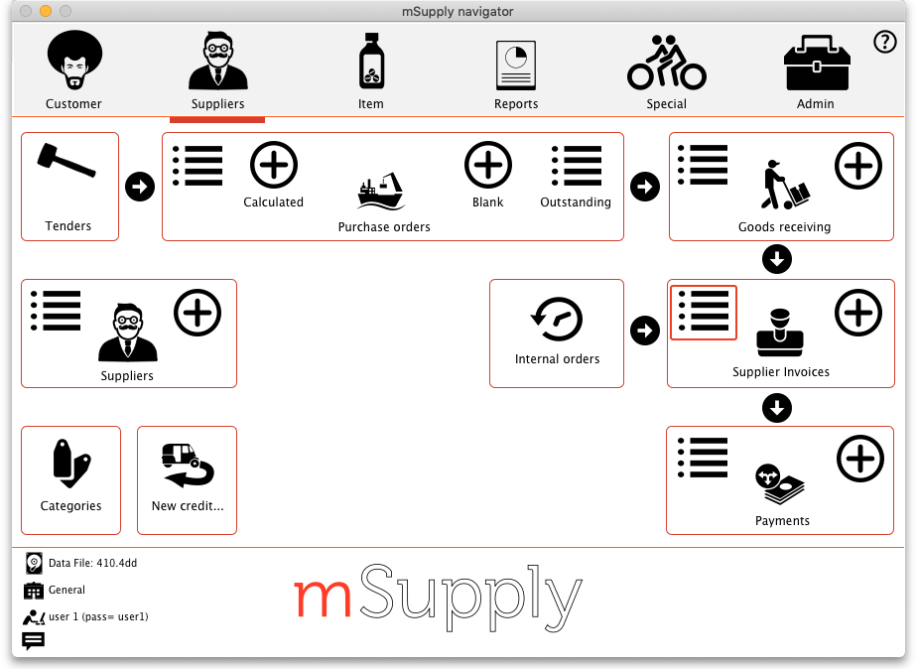
This will show you the search filter window:
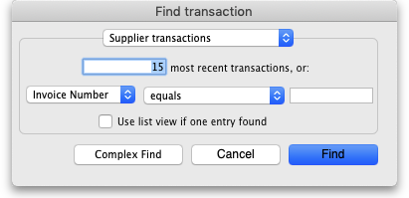
Note that the drop down list at the top is set to Supplier transactions. Edit the other filter selections as required (leave the top drop down list as it is) and click on the OK button to see a list of all supplier transactions (invoices, credits etc.). The supplier credits are the ones with “sc” in the Type column:
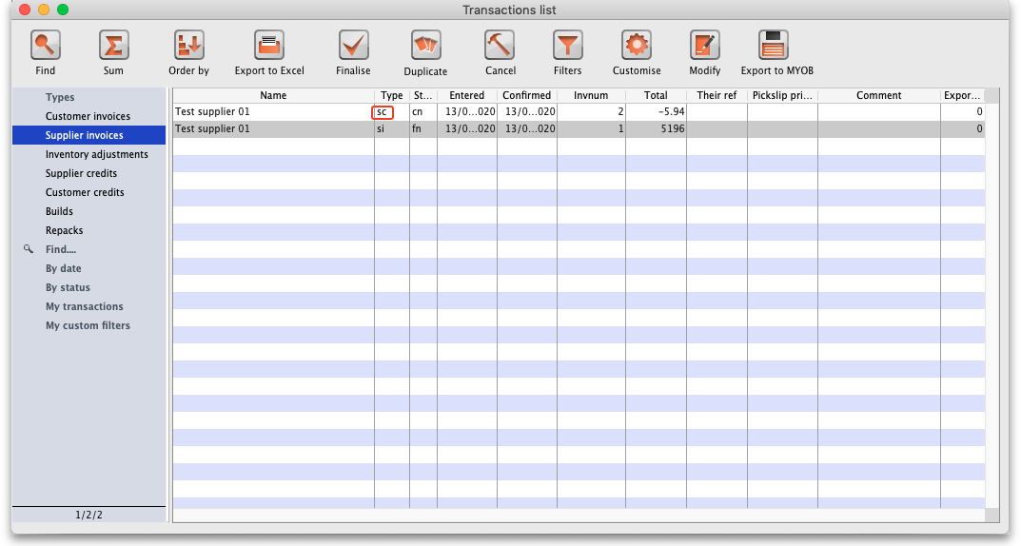
To see only supplier credits in the list you can click on the Supplier credits item on the left in that window.

Previous: 9. Returning Goods | | Next: 9.02. Receiving goods back from a customer

